**Progress made in the past week.**

1. **Added hint function for microphone**

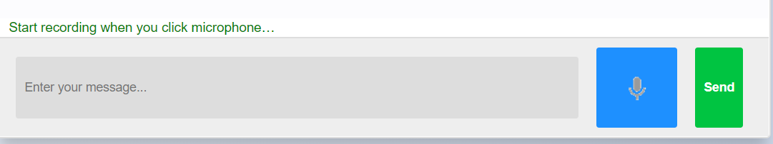

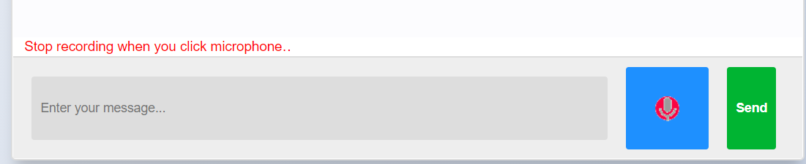

1. **Added hint function for medical options**

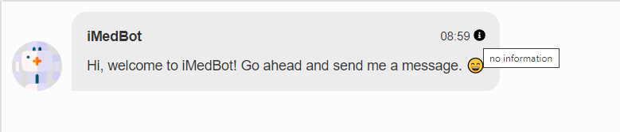

1. **Added auto complete input function**

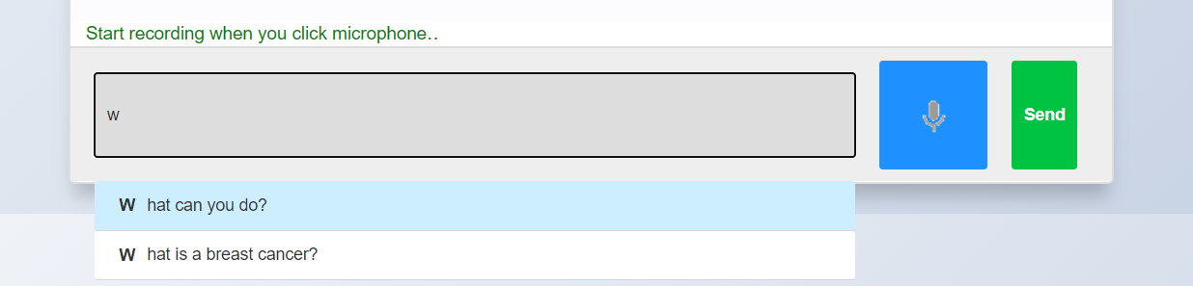

**Issues/Questions**

1. **Do we need to design some feedback form?**

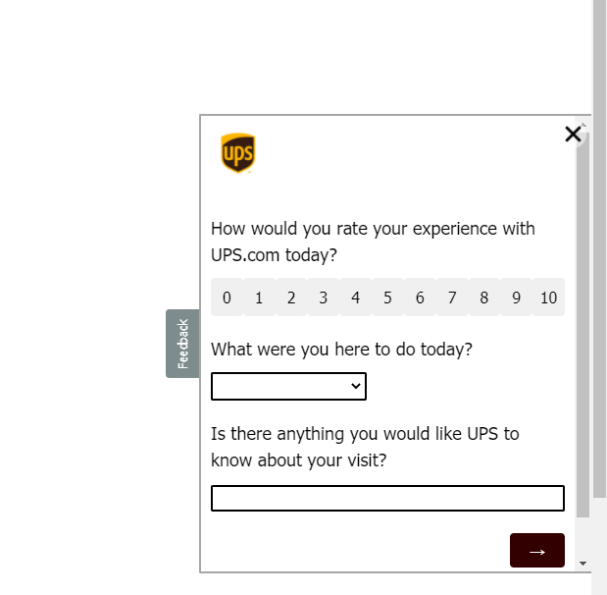

**This is too complicated. I suggest that we do some simple form of feedback such as 5-star scale rating or just two click buttons (experience good or bad), if experience is good, then we collect it as a positive user feedback, while if it is bad then we can prompt for user to enter their comments which may help to improve our tool.**

1. **Do we need to email transcript (chat history) to our customer?**

**Like this**

**No.**

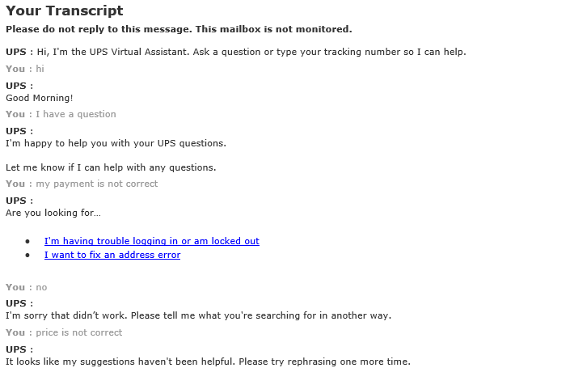

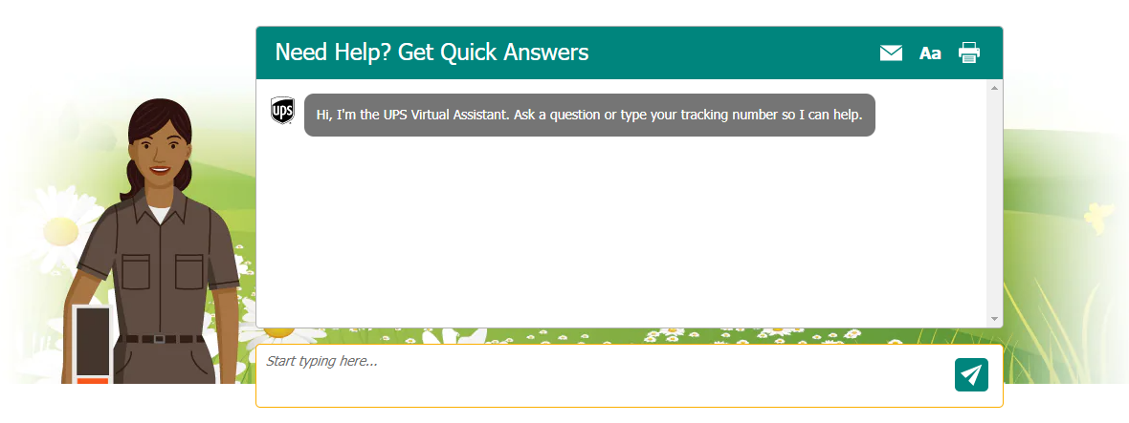

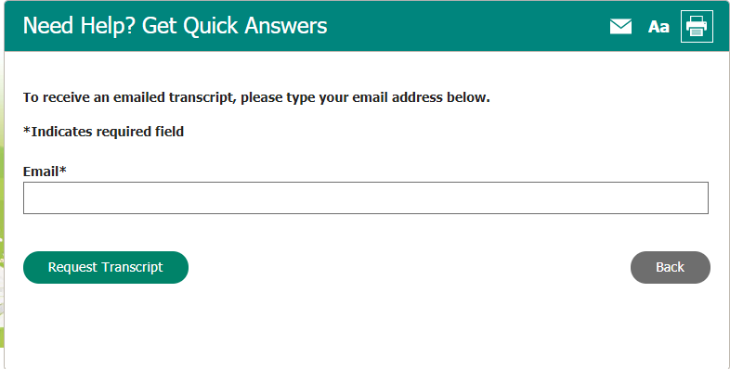

1. **We need to make our chatbot can move and can be resized by users**

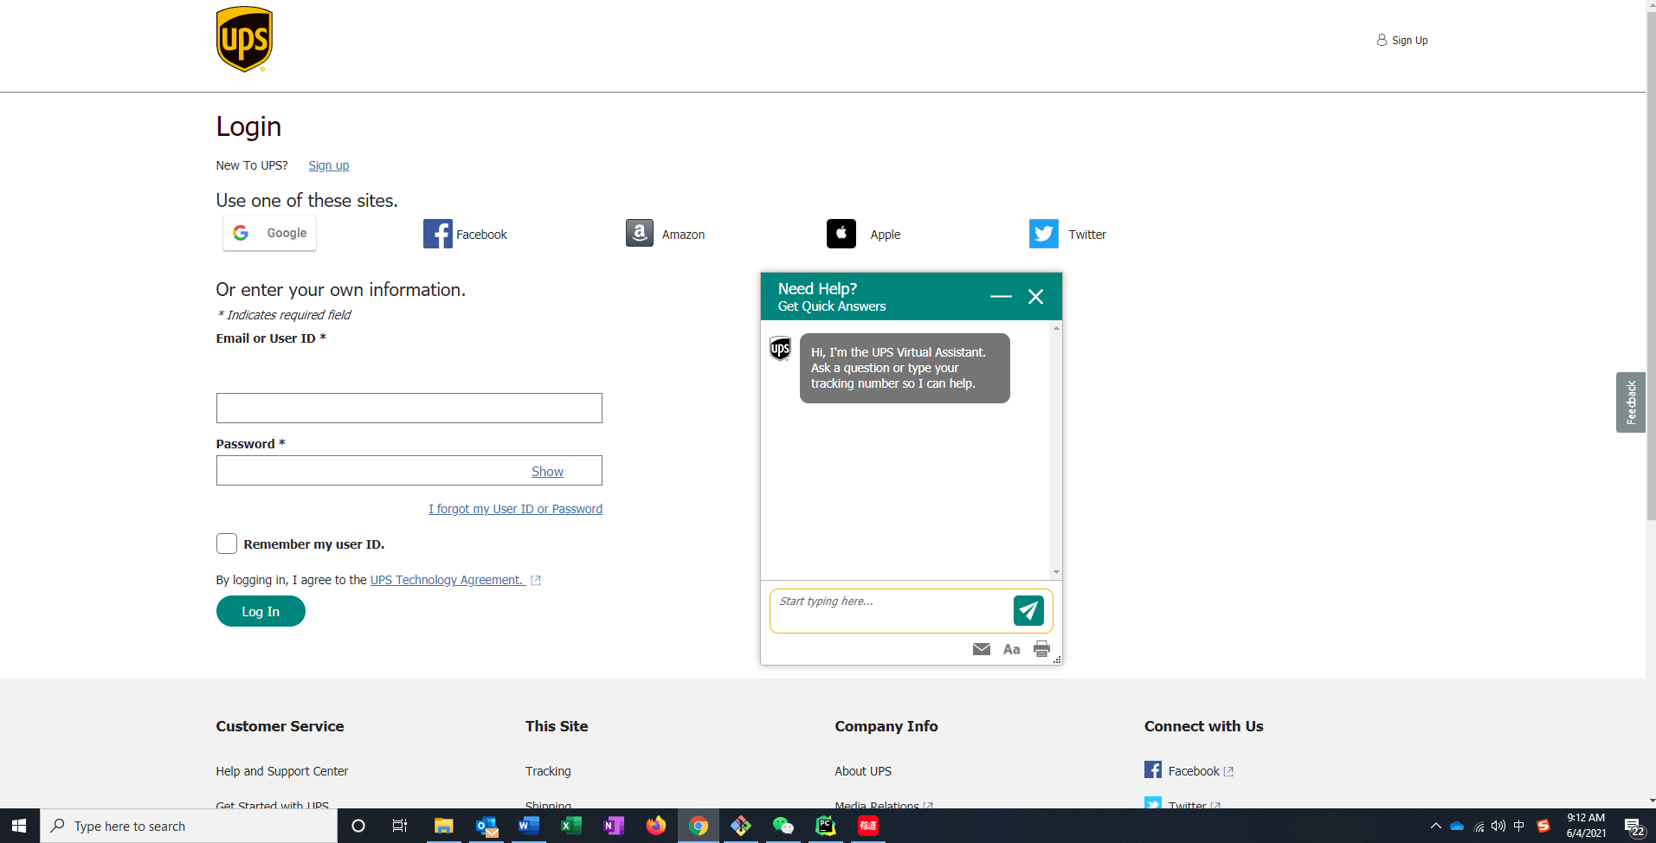

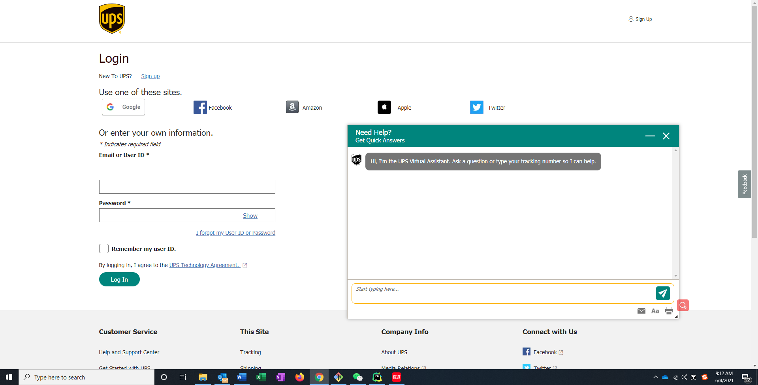

1. **FedEx online chat**
2. 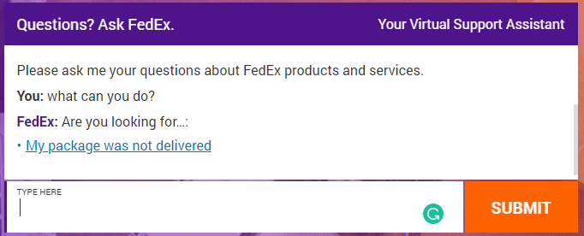

**Comments.**

**I tested the text-chat function further. Currently it does not do much but give nonsenses (See the screenshot below).**

**Ongoing tasks that cover more than a week**

1. **Improving iMedBot**
2. **Upgrade two servers (****dbgap and dbgap2)**

**Specific tasks for the coming week**

1. **Input and organize the references and literature that you previously found. Need to have this done ASAP. I have already added a bunch of references in the collaborative groups, which can serve as examples.**

**Done**

1. **voice**

**I added some conversations according to this website**

**<https://www.cancer.org/cancer/breast-cancer/understanding-a-breast-cancer-diagnosis/questions-to-ask-your-doctor-about-breast-cancer.html>**

1. **Optimize the performance of the texting conversation, which currently can’t even carry on more than a couple of sensible message exchanges. (See my comments above).**

**I tried to achieve two ways, click the button or text answer, but if I just text 5 year, the robot will use their own package to analyze it and give related answers. So I added (please click the button) for every button conversation to remind users to click instead of texting**

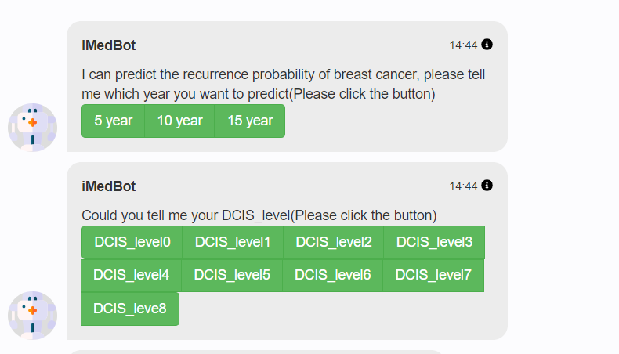

1. **Method for deploying the tool. Meaning, how would we let common user to start and run the tool. We can’t expect that a user knows how to install and run python packages.**

**We can deploy our project to our server then buy a domain, so the users can get access to our project buy specific link.**

1. **Server update. You can start by sending IT tickets for accessing the two servers (see ongoing tasks). Keep records of your IT tickets and copy me for all email communications with relevant personnel such as IT regarding this issue.**

**Less urgent specific tasks**